**Name**:

**B.N/**

**Date**:6-6-2021

**Topic**:Programming Languages

**Application Brief**:I chose this topic because I am interested in it.This field is one of the best fields for me.

**GitHub-Link:**

**GitHub-Page(Published-Website):**

**Screenshots**:

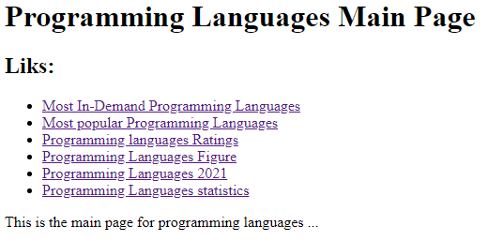

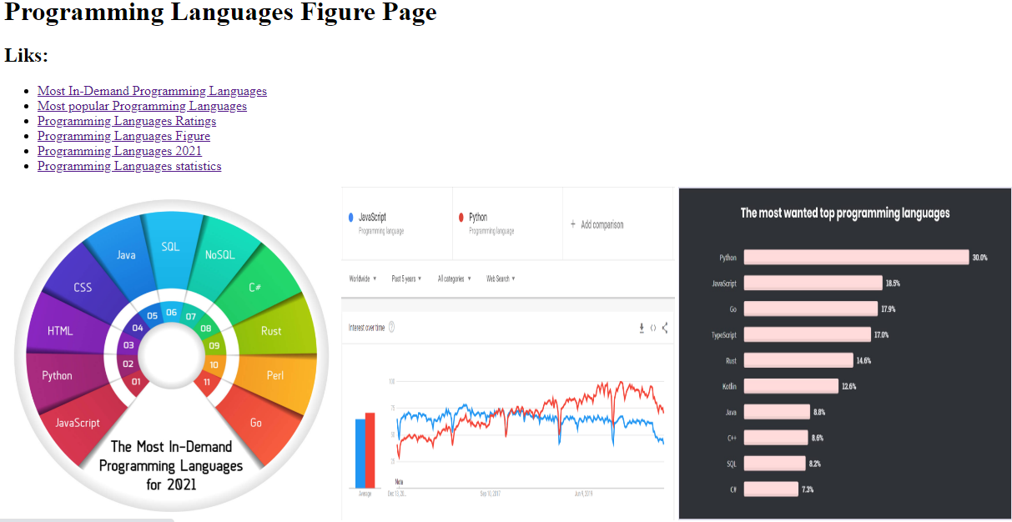

**Source Code**:

